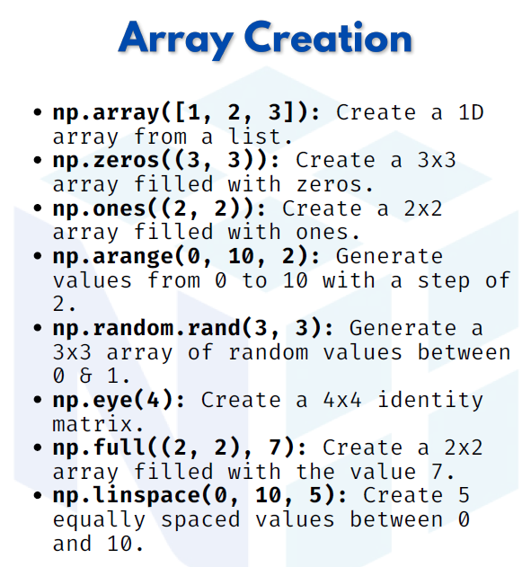

NUMPY ARRAY CREATION

1.np.array([1, 2, 3]) → Create a 1D array from a list
We can convert a normal Python list into a NumPy array using np.array().
This is the simplest way to create an array.

import numpy as np
arr = np.array([1, 2, 3])
print(arr)
Output:
[1 2 3]

2. np.zeros((3, 3)) → Create a 3x3 array filled with zeros
The np.zeros() function generates an array of given shape filled with 0s.
By default, the values are of type float.

arr = np.zeros((3, 3))
print(arr)

Output:
[[0. 0. 0.]
[0. 0. 0.]
[0. 0. 0.]]

3. np.ones((2, 2)) → Create a 2x2 array filled with ones
The np.ones() function is used to quickly make an array of all 1s.
We can also specify the data type.
arr = np.ones((2, 2), dtype=int)
print(arr)
Output:
[[1 1]
[1 1]]

4. np.arange(0, 10, 2) → Generate values from 0 to 10 with step 2
The np.arange() function works like Python’s range(), but returns a NumPy array.
arr = np.arange(0, 10, 2)
print(arr)

Output:
[0 2 4 6 8]

5. np.random.rand(3, 3) → Generate a 3x3 array of random values between 0 & 1
This function creates an array of random numbers (uniform distribution) between 0 and 1.

arr = np.random.rand(3, 3)
print(arr)

Output (example):
[[0.45 0.88 0.21]
[0.67 0.14 0.92]
[0.55 0.73 0.33]]

6. np.eye(4) → Create a 4x4 Identity Matrix
The identity matrix has 1s on the diagonal and 0s elsewhere.
arr = np.eye(4)
print(arr)

Output:
[[1. 0. 0. 0.]
[0. 1. 0. 0.]
[0. 0. 1. 0.]
[0. 0. 0. 1.]]

7. np.full((2, 2), 7) → Create a 2x2 array filled with a constant value
The np.full() function creates an array of given shape and fills it with the specified value.
arr = np.full((2, 2), 7)
print(arr)

Output:
[[7 7]
[7 7]]

8. np.linspace(0, 10, 5) → Create 5 equally spaced values between 0 and 10
This function generates values evenly spaced between a start and end point.
arr = np.linspace(0, 10, 5)
print(arr)
Output:
[ 0. 2.5 5. 7.5 10. ]

